# Spheres

|  |  |
| --- | --- |
| Name: |  |
| Class: |  |
| Period: |  |
| Date: |  |

Carefully read each question and then circle the letter of the correct answer.

1. Recall what the biosphere contains.
   1. The Earth’s crust and soils
   2. All of the planet’s water
   3. All of the planet’s living organims
   4. The ozone layer
2. State the components of the hydrosphere.
   1. The earth’s icebergs
   2. The earth’s oceans and rivers
   3. The earth’s rainfall
   4. All of the above
3. State the components of the atmosphere.
   1. Clouds, rain and gases
   2. All of the Earth’s surface
   3. All of the living things on Earth.
   4. All the gases above Earth’s surface.
4. Recall which of the following is not part of the lithosphere.
   1. Grass
   2. Soil
   3. Rocks
5. The Earth is comprised of four spheres: the atmosphere, the lithosphere, the biosphere and the hydrosphere. This picture contains the sea and seaweed. Identify the two spheres that these things are present in.

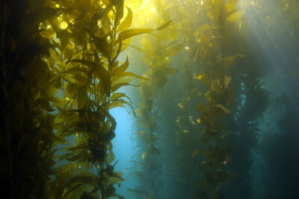

* 1. Atmosphere and hydosphere
  2. Hydrosphere and lithosphere
  3. Hydrosphere and biosphere
  4. Atmosphere and lithosphere

1. The Earth is comprised of four spheres: the atmosphere, the lithosphere, the biosphere and the hydrosphere. This picture contains the sea and the sky. Identify the two spheres that these things are present in.

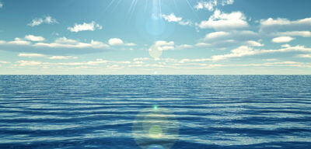

* 1. Atmosphere and lithosphere
  2. Atmosphere and hydrosphere
  3. Hydrosphere and biosphere
  4. Atmosphere and biosphere

1. The Earth is comprised of four spheres: the atmosphere, the lithosphere, the biosphere and the hydrosphere. This picture contains an animal and dirt. Identify the two spheres that these things are present in.

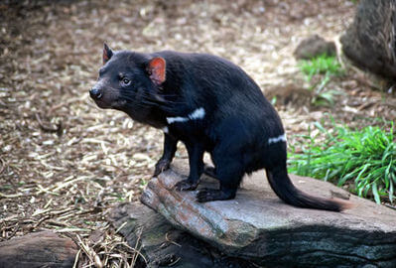

* 1. Same magnitude
  2. Same direction
  3. Different colours
  4. Opposite directions

1. State the components of the ozone molecule.
   1. Two oxygen and one nitrogen atom
   2. Three oxygen atoms
   3. Two oxygen atoms
   4. One oxygen atom and two hydrogen atoms.
2. Recall the physical state of ozone.
   1. A liquid
   2. A gas
   3. A layer of clouds
   4. A solid
3. Describe the impacts of pollutants of the ozone layer,
   1. Degraded it so it disappeared completely.
   2. Degraded it and formed a hole.
   3. Caused it to move further away.
   4. Made it thicker.

Select the correct words to fill in the spaces below.

**rocks glaciers lithosphere hydrosphere water**

The Earth’s ____________ is made up of all the ______________ on our planet. This includes all of the salt water oceans, fresh water lakes, ______________ and underground deposits.

The ____________ includes all _____________ and geological structures on which exists such as soil, rocks and mountains.

**stratosphere absorb earth’s surface reducing**

The role of the ____________ is to ____________ the UVB radiation from the sun, ____________ the amount of UVB radiation making contact with the ______________.

**unstable gases sun stable weather biosphere atmosphere**

The _____________ is made up of all areas of the earth and its atmosphere that contains life.

The _____________ contains all the ____________ above Earth. Parts of the atmosphere contain the _______________ and greenhouse gases that keep Earth’s temperatures _______________.

Short Answer

1. The Earth is comprised of four spheres: the atmosphere, the lithosphere, the biosphere and the hydrosphere. Identify the different parts of the image that belong to each sphere.

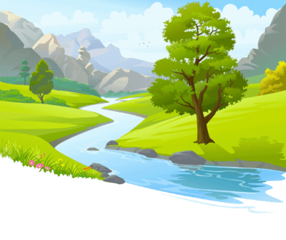

1. Discuss how a natural event in one sphere, such as a natural disaster like a tsunami, has the potential to affect another sphere.

Try to include all of the four spheres in your answer.

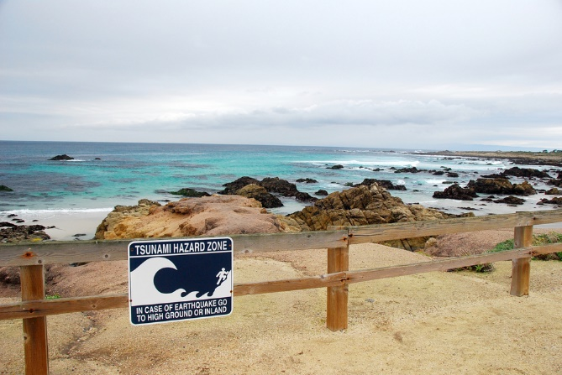

1. Identify how the ozone layer normally functions, and explain what happens when it is degraded?

Hint: think about the rates of skin cancer in Australia in the last few decades.

1. The Earth is comprised of four spheres: the atmosphere, the lithosphere, the biosphere and the hydrosphere.

Identify the different parts of the image that belong to each sphere.